SWE20004 Technical Software Development Semester 1 2019

Assignment 1 report

Name: Franz Tamani Student ID:102114822

Lab class: Thursday / 4:40 / EN302 Tutor: Gavin Chan

Due Date: Tuesday 9th April 2019 at 11:59 pm

Date Submitted: Wednesday 29th August 2017 at 11:59pm

Assignment Title: 1

Program description

The application aims to solve the problem of securely transmitting a 2-8(inclusive) digit number. The program encodes the numbers differently depending on its length, the user is asked if extra protection is wanted for 8-digit numbers so that the program can add extra security to it. The program then decodes the encoded numbers so that the original numbers can be read.

Inputs and Outputs
The inputs and outputs for this program are described in Table 1.

Table 1. Data dictionary:
Data to be stored | Sample data | Type of data | C++ type | Input method | In /  Out | Variable name
User Input | 35836 | Integer | int | cin | cout | Input
Encoded Numbers | “12345” | Text | string | cin | cout | encoded
Decoded Numbers | “12345” | Text | string | cin | cout | decoded
Extra Protection for 8 digits | True | Boolean | bool | cin | cout | extraProtection

3. Algorithm
Program steps:
  - START
  - Prompt user for input.
  - Enter number.
  - Check if input is valid – if not return to a.
  - Output “Input Number: “ … to console.
  - Pass input, encoded(unassigned), &extraProtection(false) variables to encode_numbers() method.
  - Check input length.
  - If length < 8 Encode Accordingly
  - If length equal 8 Prompt User for Input (yes/no).
  - Check if input is valid – if not return to h.
  - If yes set extraProtection to true and add extra protection.
  - Output “Encoded Number: …” to console.
  - Pass decoded(unassigned), encoded, extraProtection(false) number to decode_numbers method.
  - If extraProtection is true, remove/decode extra protection.
  - If length equal 2 to 3, decode accordingly.
  - If length equal 4 to 8 decode accordingly.
  - Output “Decoded Number: …” to console.
  - END

Coding logic:
- If digits equal 2 or 3
  - Reverse order (this switches the last places for 2 and 3 digit numbers as the middle number in a 3 digit input will stay in the middle).
- If digits greater than or equal 4 and less than or equal to 8;
  - j = 1;
  - For each digit from right(end) to left(start), add j and get remainder of the sum, replace the value in the array with the result.
  - j ++
  - repeat until process has been done to all numbers.
- If digit equal 8
  - ask user if user wants extra protection, if yes reverse order of the number result from the step above else, do nothing.

Decoding logic:

- If extraProtection is true/added reverse order else do nothing.
- If digits equal 2 or 3.
  - Reverse order (this switches the last places for 2 and 3 digit numbers as the middle number in a 3 digit input will stay in the middle).
- If digits greater than or equal 4 and less than or equal to 8;
  - j = 1;
  - For each digit from right(end) to left(start), add 10 and subtract j and get remainder of the sum, replace the value in the array with the result.
  - j ++
  - repeat until process has been done to all numbers.

Source code:

/*
Name: Franz Tamani
StuID: 102114822
FileName: Assignment1.cpp
Description: The program encodes and decodes a number between 2-8 digits(inclusive)
that is entered by the user so that it can be sent securely.
*/

#include<iostream>
#include<string>

using namespace std;

//Converts a character to an integer.
int char_to_int(char c)
{
return (int)c - '0';
}

//Converts an integer into a character.
char int_to_char(int i)
{
return (char)i + '0';
}

//Reverses order of the string, used for 2-3 digits, as it switches the first and last digits.
//Also used for reversing the order for 4-8 digits as numbers are read from right to left.
void reverse_order(string& s)
{
reverse(s.begin(), s.end());
}

//Used for encoding 4-8 digits.
void four_eight_encode(string& s)
{
int number;
int j = 1;
for (int i = s.size() -1; i >= 0; i--)
{
number = char_to_int(s[i]); //Converts character to integer so we can treat it as an integer(add subtract etc.).
number += j; //Adds the position of the number (right to left, from 1-8)
number = number % 10; //Gets the remainder.
s[i] = int_to_char(number); //Converts the integer back to a character
j++;
//cout << "number = " << number << endl; //Used to make sure numbers are being correctly encoded.
}
}

//Used for decoding 4-8 digits.
void four_eight_decode(string& s)
{
int number;
int j = 1;
for (int i = s.size() - 1; i >= 0; i--)
{
number = char_to_int(s[i]); //Converts character to integer so we can treat it as an integer(add subtract etc.).
number += 10 - j; //Adds 10 and subtracts the position of the number (right to left, from 1-8)
number = number % 10; //Gets the remainder
s[i] = int_to_char(number); //Converts the integer back to a character
j++;
//cout << "number = " << number << endl; //Used to make sure numbers are being correctly decoded.
}
}

//Encodes Numbers
void encode_numbers(int inputNumbers, string& encoded, bool& extraProtection)
{
bool validInput = false;
string input;

encoded = to_string(inputNumbers); //Changes input to string so it can be used more easily.

//Reverses order for 2-3 digits as the middle digit for numbers with 3 digits will always stay in the same spot.
if (encoded.size() == 2 || encoded.size() == 3)
{
reverse_order(encoded);
}
else if (encoded.size() >= 4 && encoded.size() <= 8) // Encodes numbers with 4-8 digits
{
four_eight_encode(encoded);
if (encoded.size() == 8)
{
cout << "\nDo you want to add Extra Protection (y/n)?" << endl; //Asks if extra protection us wanted, if so reverses the number order.

//switch
while (!validInput)
{
cin.clear();
cin >> input;

if (input == "y" || input == "yes")
{
extraProtection = true;
validInput = true;
}
else if (input == "n" || input == "no")
{
//extraProtection false by default so we don't do anything here.
validInput = true;
}
else
{
input = ""; //Clears whatever was set to input.
cout << "Enter 'y'/'n' or 'yes'/'no'" << endl;
}
}

if (extraProtection)
{
cout << "Adding Extra Protection" << endl;
reverse_order(encoded);
}
}
}
}

//Decodes the encoded numbers
void decode_numbers(string& decoded, string encoded, bool extraProtection)
{
decoded = encoded;
if (extraProtection) //Checks if extra protection was added, if so reverses the number order.
{
reverse_order(decoded);
}
// Reverses order for 2 and 3, same way as they were encoded in the first place.
if (decoded.size() == 2 || decoded.size() == 3)
{
reverse_order(decoded);
}
else if (decoded.size() >= 4 || decoded.size() <= 8) //Used for decoding numbers with 4-8 digits.
{
four_eight_decode(decoded);
}
}

int main()
{
int input; //input used for getting user input.
string encoded, decoded; //encoded and decoded used for storing encoded and decoded numbers
bool extraProtection = false; //used for encoding and decoding of 8 digit numbers
bool inputValid = false; //used for checkin invalid input

//Gets input from user
//Makes sure that the input is correct.
while (!inputValid)
{
cout << "Please Enter a 2 - 8 digit number" << endl;
cin >> input;

if (input < 0)
{
cout << "Not a valid input, re-enter the number" << endl;
}
else if (input > 0)
{
encoded = to_string(input);
if (encoded.size() < 2 || encoded.size() > 8)
{
cout << "Only 2 to 8 Digits accepted, re-enter the number" << endl;
}
else {
inputValid = true;
}
}
else if (cin.fail())
{
cout << "That is not a valid input" << endl;;
cin.clear();
cin.ignore(80, '\n');
}
}

//Outputs the input number
cout << "\nInput Number: " << input << endl;

//Encodes numbers.
encode_numbers(input, encoded, extraProtection);
cout << "\nEncoded Number: " << encoded << endl;

//Decodes numbers if there are no errors from encoding
//Sends over decoded number and bool dictating if extra protection was added
decode_numbers(decoded, encoded, extraProtection);
cout << "\nDecoded Number: " << decoded << endl;
}

Screenshots showing working program (Show all possible outcome):
Incorrect Number Inputs
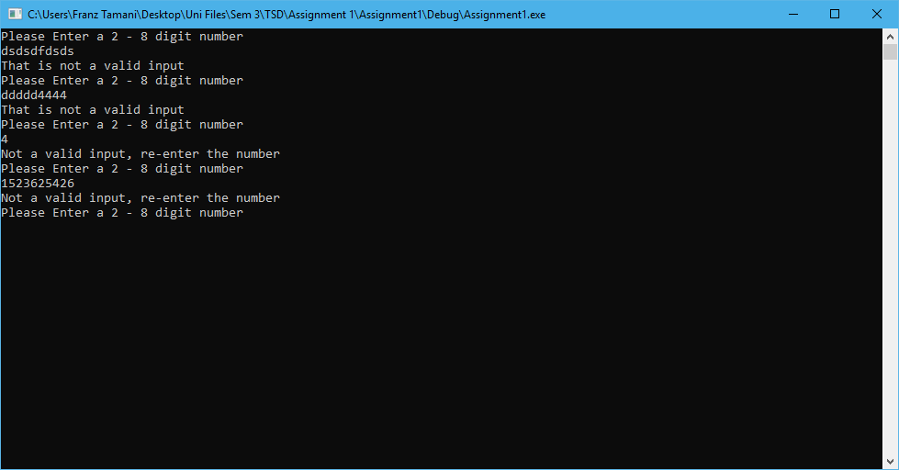
2 Digits
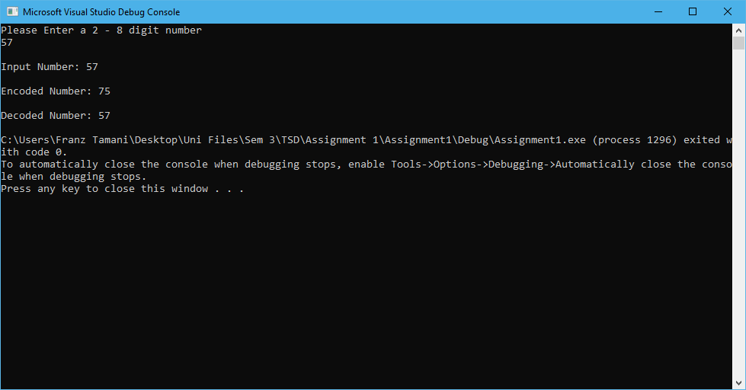

3 Digits
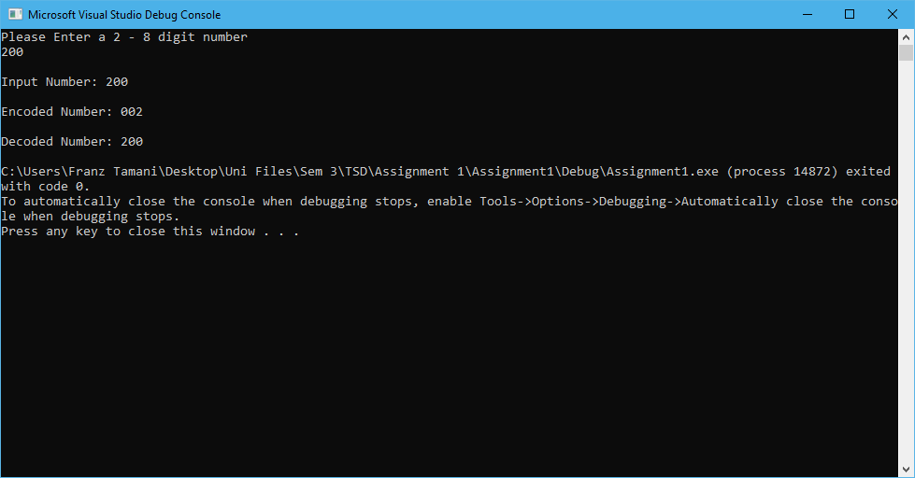
4 Digits
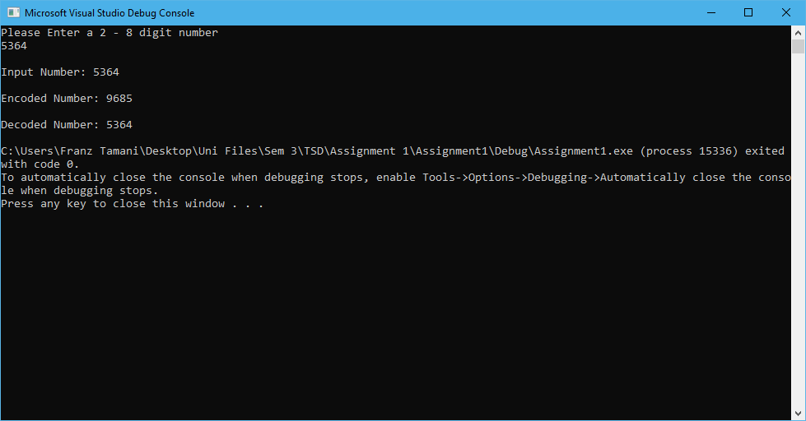
5 Digits
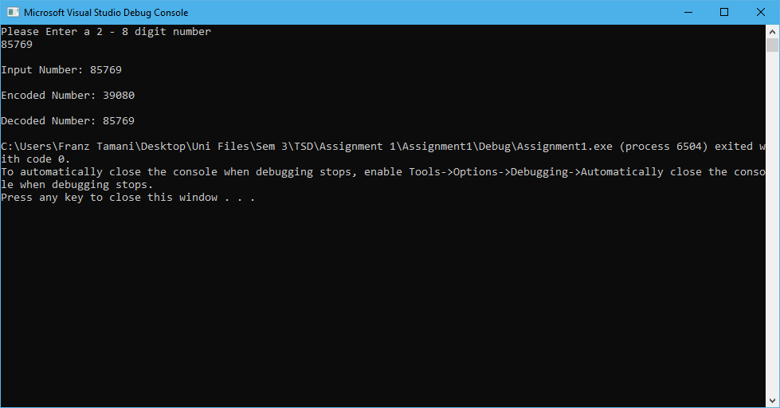
6 Digits
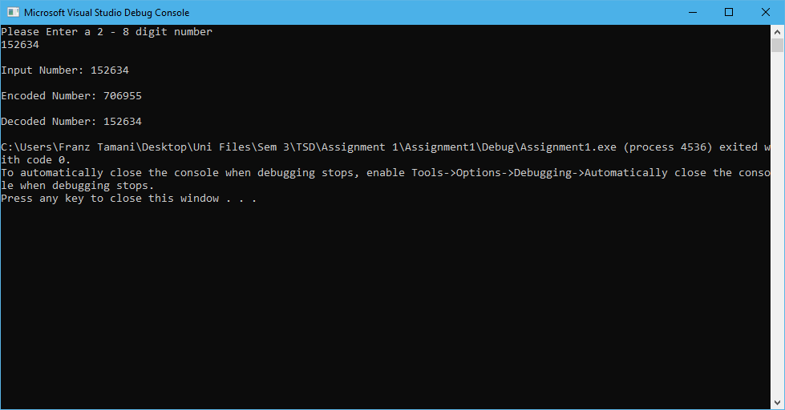
7 Digits
8 Digits w/o Extra Protection
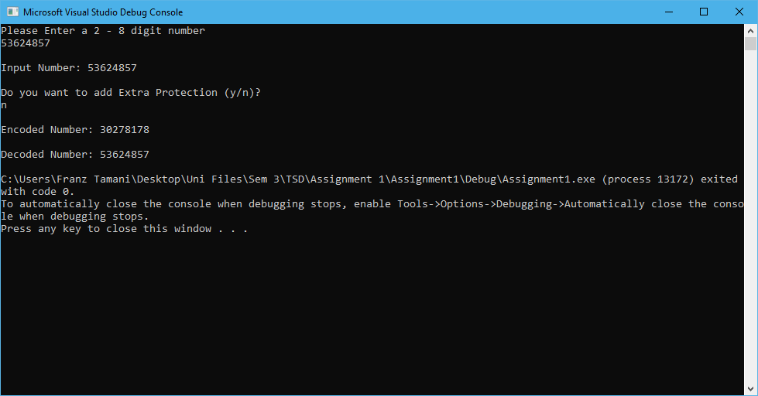
8 Digits w/Extra Protection
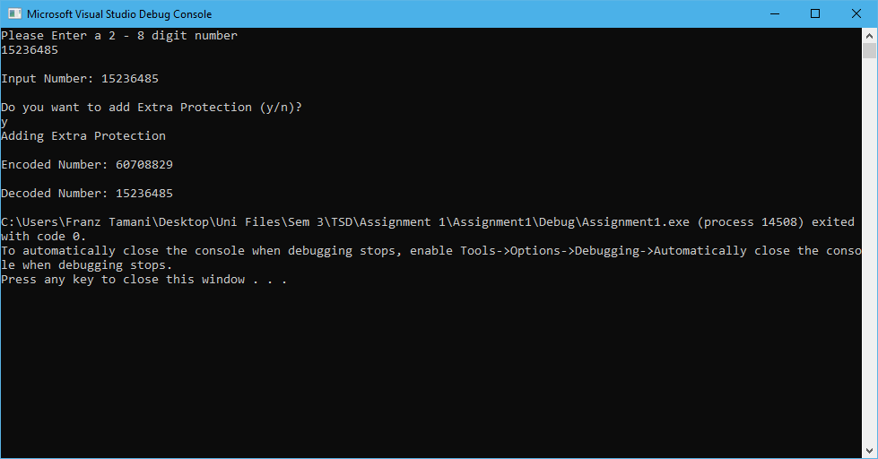
Extra Protection Incorrect Inputs
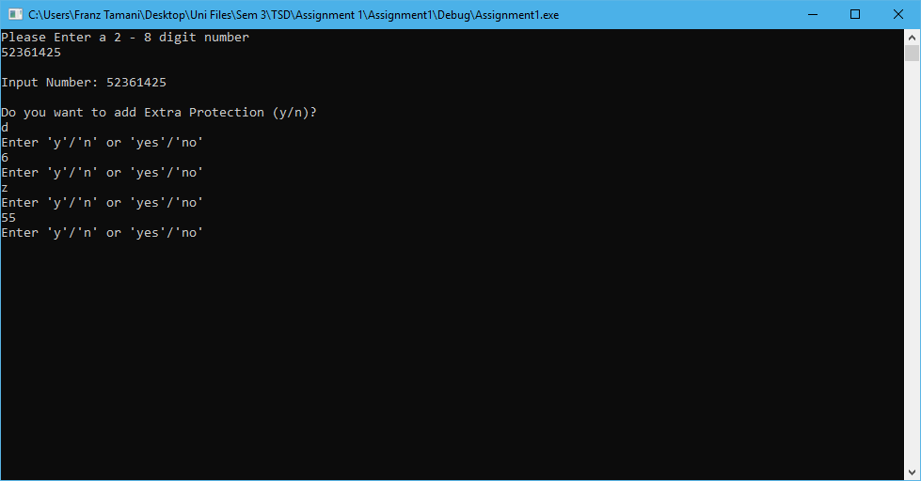

Task 2.10

Program description
The program calculates the current flowing through an AC circuit given Frequency, Resistance, Capacitance, Inductance and Voltage.

Source Code
////////////////////////////////////
//// Task2.10 ////
///////////////////////////////////

#include<iostream>
#include<cmath>
#include<iomanip>

#define PI 3.14159

/*
Calculates current using the given parameters:
R = Resistance in Ohms
F = Frequency in Hertz
C = Capacitance in Farads
L = Inducatance in Henrys
E = Electromotive Force in Volts
*/
double CalCurrent(double R, double F, double C, double L, double E)
{
double result, rSQ, twoPFL, twoPFC;

rSQ = pow(R, 2); // R^2
twoPFL = 2 * PI * F * L; // 2 * Pi * Frequency * Inductance
twoPFC = 1 / (2 * PI * F * C); // 1 / (2 * Pi * Frequency * Cappacitance)
result = E / sqrt(rSQ + pow((twoPFL - twoPFC), 2));
// result is current(I)
// result = EMF / SquareRoot(Resistance^2 + ((2 * Pi * Frequency * Inductance) - (1 / 2 * Pi * Frequency * Capacitance))^2)
return result;
}

/*
Calculates Resonant Frequency from given parameters:
L = Inductance
C = Capacitance
*/
double CalcResFreq(double L, double C)
{
double result, sqrtLC, twoPI;
sqrtLC = sqrt(L * C);
twoPI = 2 * PI;
result = 1/(twoPI * sqrtLC);
return result;
}

int main()
{
double current, emf, resistance, frequency, inductance, capacitance, resFreq;

std::cout << "Enter the Resistance, Frequency, Capacitance, Inductance and EMF." << std::endl;
std::cout << "Resistance(Ohms): ";
std::cin >> resistance;
std::cout << "Frequency(Hertz): ";
std::cin >> frequency;
std::cout << "Capacitance(Farads): ";
std::cin >> capacitance;
std::cout << "Inductance(Henrys): ";
std::cin >> inductance;
std::cout << "Electromotive Force(Volts): ";
std::cin >> emf;
// Calculates current from given parameters
current = CalCurrent(resistance, frequency, capacitance, inductance, emf);
// Displays calculated current/result
std::cout << "I(Current) = " << current << "A" << std::endl;
//Caculates resonant frequency
resFreq = CalcResFreq(inductance, capacitance);
//Displays Resonant Frequency.
std::cout << "The resonant frequency is: " << resFreq << std::endl;
//Keeps console open till enter is pressed
std::cin.get();
std::cin.get();

return 0;
}

////////////////////////////////////
////Name: Franz Jordaneal Tamani////
////StuID: 102114822 ////
///////////////////////////////////

Screenshots showing working program
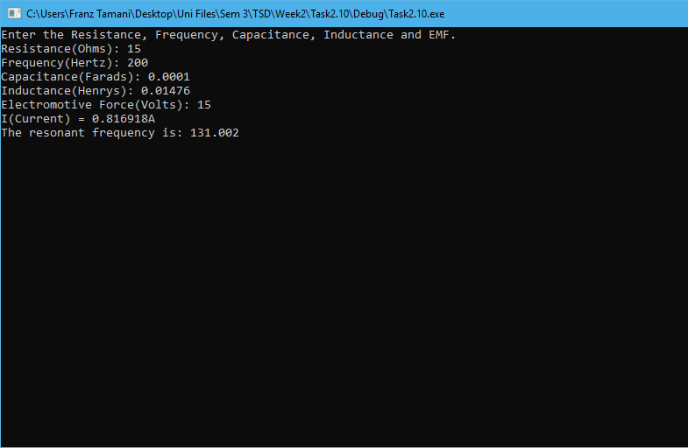

Task 3.8

Program description
The program displays a computer’s information in a formatted fashion, given user input.

Source Code
////////////////////////////////////
////Name: Franz Jordaneal Tamani////
////StuID: 102114822 ////
////////////////////////////////////
#include<iostream>
#include<cmath>
#include<string>
#include<iomanip>

using namespace std;

int main()
{
string user, employee, macAddress, pcSerial;
short int ip1, ip2, ip3, ip4, cores;
char pcType;
double cpuSpeed;
unsigned int IP;

cout << "Please enter the user name: ";
getline(cin, user); //User can have space in it
cout << "Please enter the employee name: ";
getline(cin, employee); //employee name can have space in it

cout << "Please enter the PC serial number (max 10 characters): ";
cin >> pcSerial;
cout << "Please enter the PC type (S = Server, D = Desktop, L = Laptop, T = Tablet, P = Phone): ";
cin >> pcType;
cout << "Please enter the number of cores: ";
cin >> cores;
cout << "Please enter the CPU speed (GHz): ";
cin >> cpuSpeed;
cout << "Please enter MAC Address: ";
cin >> macAddress;
cout << "Please enter IPV4 without dots (e.g. 102 192 168 1): ";
cin >> ip1 >> ip2 >> ip3 >> ip4;

//cout << "ip1 = " << ip1 << "ip2 = " << ip2 << "ip3 = " << ip3 << "ip4 = " << ip4 << endl;

IP = ip1 * pow(256.0, 3) + ip2 * pow(256.0, 2) + ip3 * 256.0 + ip4;

cout << "+" << setfill('=') << setw(78) << "+" << endl;
cout << setfill(' ');
cout << "| User:" << setw(10) << user;
cout << "| Employee:" << setw(24) << employee;
cout << "| Serial:" << setw(15) << pcSerial << " |" << endl;

cout << "+" << setfill('-') << setw(78) << "+" << endl;
cout << setfill(' ');
cout << "| Type:" << setw(5) << pcType;
cout << "| Cores:" << setw(5) << cores;
cout << "| Speed:" << setw(5) << cpuSpeed;
cout << "| MAC:" << setw(16) << macAddress;
cout << "| IP:" << ip1 << "." << ip2 << "." << ip3 << "." << ip4 << " |" << endl;

cout << "+" << setfill('-') << setw(78) << "+" << endl;
cout << setfill(' ');
cout << "|" << setw(21) << " ";
cout << "IP address as integer:" << IP;
cout << setw(23) << "|" << endl;

cout << "+" << setfill('=') << setw(78) << "+" << endl;
}

Screenshots showing working program
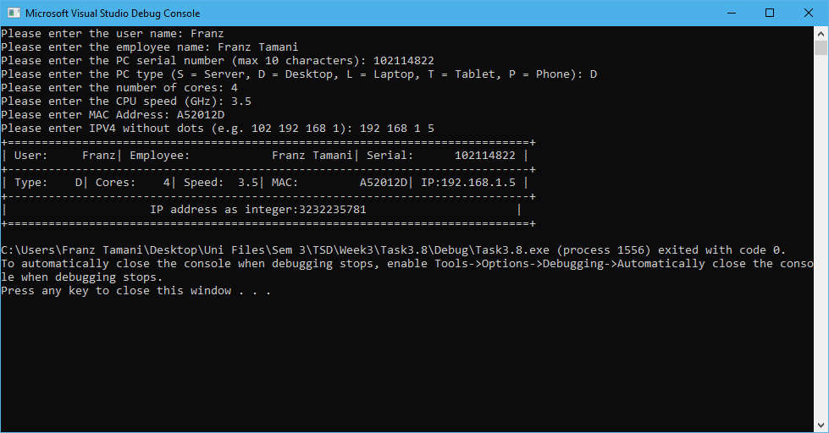

Task 4.8

Program description
The program either adds, multiplies or divides 2 decimal numbers that is given by the user. The user also chooses what they want to do with the 2 numbers.

Source Code
////////////////////////////////////
////Name: Franz Jordaneal Tamani////
////StuID: 102114822 ////
////////////////////////////////////
#include<iostream>
#include<string>

using namespace std;

int main()
{
double dec1, dec2;
int choice;
bool exitProgram = false;

do
{
cout << "Enter 2 decimal numbers" << endl;
cin >> dec1 >> dec2;

cout << "Press 1:Addition, 2:Multiplication, 3:Division" << endl;
cin >> choice;

switch (choice)
{
default:
while (choice != 1 && choice != 2 && choice != 3)
{
cout << "Enter a Valid Number" << endl;
cout << "Press 1:Addition, 2:Multiplication, 3:Division" << endl;
cin >> choice;
}
case 1:
cout << "Result: " << dec1 + dec2 << endl;
break;
case 2:
cout << "Result: " << dec1 * dec2 << endl;
break;
case 3:
cout << "Result: " << dec1 / dec2 << endl;
break;
}

//Asks User if they want to continue or exit
cout << "Press 1:Continue 2:Exit" << endl;
cin >> choice;

switch (choice)
{
default:
while (choice != 1 && choice != 2 && choice != 3)
{
cout << "Enter a Valid Number" << endl;
cout << "Press 1:Continue 2:Exit" << endl;
cin >> choice;
}
case 1:
continue;
case 2:
exitProgram = true;
}
} while (!exitProgram);

}

Screenshots showing working program

